**“Recommendation Engine for Movies Portal”**

**7th Semester Mini Project Report**



**Under The Guidanceof Prof. Dr. Ranjana Vyas**

**IIT-Allahabad**

**By-**

**Shweta Choudhary (RIT2012025)**

**Nakshatra Maheshwari(RIT2012074)**

**ShashankSharma (RIT2012075)**

**INDIANINSTITUTE OFINFORMATIONTECHNOLOGY ALLAHABAD**

(AUNIVERSITY ESTABLISHED UNDERSEC.3OFUGCACT, 1956VIDENOTIFICATION NO.F.9-4/99-U.3DATED 04.08.2000

OF THEGOVT. OF INDIA)

ACENTREOFEXCELLENCEININFORMATION TECHNOLOGY ESTABLISHED BY GOVT. OF INDIA

**November,2015**

**CANDIDATES’DECLARATION**

We hereby declare that the work presented in this project report entitled “Recommendation Engine for Movie Portal”, submitted towards completion of 7th Mid-Semester report of B.Tech. (IT) at Indian Institute of Information Technology, Allahabad, and is an authenticate record of our original work performed from July 2015 to Dec 2015 under the supervision of Dr. Ranjana Vyas. Due acknowledgements have been made in the text to all other material used. The project will be performed in full compliance to meet the stated objective with the stated Requirements and coping up with the constraints of the prescribed curriculum.

Date:

Place:Allahabad

Shweta Choudhary (RIT2012025)

NakshatraMaheshwari (RIT2012074)

Shashank Sharma (RIT2012075)

**CERTIFICATE**

It is to state that the statement above made by the group is correct and appropriate to best of my knowledge .This work taken up as 7th semester mini-project by the above stated group is being performed under my supervision and guidance.

Date:

Place: Allahabad

Dr. Ranjana Vyas

IIIT-Allahabad

**Contents**

1. Abstract…………………………………………………………………………………….….1

2. Introduction…………………………………………………………………………………....1

3. Problem Definition……………………..……………………………….……………………..1

4. Literature Survey……………………………………………………………………………....2

5. Proposed Methodology………………………………………………………………………...2

6. Hardware and Software Requirement………………………………………………………….4

7. Work done before mid-Semester…………………………………………………...………….4

8. After Mid-semester…………………………………..………………………………………...5

9. Result…………………………………………………………………………………………. 13

10. References……………………………………………………………………….…………...14

**1. Abstract**

Which movie I should watch tonight? Ever wonder how difficult this question could be if someone asks you to recommend the best movie? Best in terms of what? How this best is defined?

MOVIES fascinate every individual despite of his religion, age, zone, sex, and taste. Due to infinitely large number of movie options available for a user of specific taste, it is of utmost importance to develop a system that could recommend best movie (suited most to user preference). Many such systems have already been developed. But some of them recommend movies of a certain genre while some of them could not recommend to cold-start user. In this project, we aim to develop a system which is best in itself in terms of recommending as it is taking average value from available sources as well as user present needs and taste. Not only this but also, by taking average value, the cases of fraud ratings of already rated sites become lower in our recommendation, making it more reliable than present existing ones.

**2. Introduction**

In this dynamic world, where too much of information is available which keeps changing and increasing every minute, choosing domain of available options is indeed very large. Due to abundance of data floating everywhere, choosing one that is best suited to meet our demands and preferences is most times a very tedious job. Not only is this but it time consuming also. Therefore if we could rely on a system who can do this task for us and that too with accepted amount of accuracy, is definitely be a boon not only for problem solving in general, but also for specific individual in particular. Recommender system is the key.

Recommender systems are an important part of the information and e-commerce ecosystem. Whenever we talk of data which is exponentially large in comparison to a relatively small subset of options that are of interest, recommender system have always proved its existence. Recommender system takes input from user (say preferences, taste, necessity etc.), apply some apt algorithm on it and produce the recommender output for distinct user. Our recommendation engine will not only be based on available ratings but also on the distinct taste of individual user.

* Taking of various options available, the first question that arises is why movies only?

**The answer to this question lies on the fact that every individual despite of age, zone, sex, taste needs ENTERTAINMENT.**

Why movie recommendation is the need of the hour?

* Preferably very large number of choices available.
* Drastically reduces the domain of choices.
* Movies guarantee entertainment (attracts user of all age groups).
* How our system is superior to the ones already existing?
* **“MAKE IN INDIA” approach.**
* More reliable dataset and in turn more accurate outcome.
* Can deal with fake ratings.

**3. Problem Definition and Objectives**

Why to depend on foreign movies dataset to produce movie Recommendation system algorithms?

* We will have complete Indian movies dataset where user can login and rate movies of their choices.
* We will also use ratings provided by different websites to produce collaborative rating for the recommendation-minimal false recommendation.
* Using the above information and applying algorithms for predicting rating, top movies will be recommended to the users.

**Objectives:-**

* Build dataset for Movie Recommender System.
* Choice of Algorithm for predicting ratings :-
  + Cosine similarity method to find similar users.
  + Matrix factorization techniques.

**4. Literature Survey**

Recommender systems emerged as an independent research area in the mid-1990s when researchers started focusing on recommendation problems that explicitly rely on the ratings structure.

Collaborative Filtering is the best technique for proposing individual recommendations to a user considering all parameters including his taste, zone, preferences, dislikes .Individual user should always feel as if the system is defined only for him giving him the most of what he desires.

**4.1 Collaborative Filtering**

The collaborative filtering algo works on the basis of user with similar interest. The main idea around which this theory is centered is to match people having similar preferences. It Recommends depending on neighbors. Neighbors –user with most similar taste to the user considered at that very moment.

**4.2 Similarity Measures [2]**

Similarity measure reflects the degree of closeness or separation of the target objects and should correspond to the characteristics that are believed to distinguish the object/group of object where the target object belongs.

**4.2.1Euclidean Distance**:-Euclidean distance is a standard metric for geometrical problems.

**4.2.3 Cosine Similarity**:-Cosine similarity is a measurement of similarity between the two vectors of an inner product space that measure the cos of the angle between them.

D:\cosine.jpg

**5. Proposed Methodology And Complete Overview**

**Overview 🡪**

Scrap Data from various websites

Data Cleansing

Store clean data in

Database

Algorithm for predicting ratings

Display Output

* Collect data about movies (Year, Genre, Artist, etc.). Wikipedia is the best source to collect Indian movies data.
* Scrap the movies rating from various rating websites, like, **Timesofindia.com, Imdb.com, Bollywoodhungama.com, Ndtv.com, Glamsham.com, Rottentomatoes.com, etc.**
* Apply Data Cleansing to remove noise and clean Data.(Using Heuristic Levenshtein distance)
* Normalize the Schema for storing the above clean data in database.
* Algorithm for predicting ratings.
* Output->Display the recommended movies to the users.

**5.2APPROACH: Data Cleaning**

* We use different approaches for this (and for most efficiency we mix them all):
* Ignore everything that is in parenthesis.
* Breaking down into cases based on Artist, Genre, etc.
* Define words automatically drop like “movie”, “new”, etc.
* Make a dictionary of feature set (Genre, Year of release, etc.) for different catalog which should be same while declaring any movie as common movie.
* Compare the names via their Levenshtein distance [5] and use this distance for clustering.
* Heuristic Levenshtein distance [5].
* If there are n movies, then overall complexity= (O(n2l2), where l=product title length

**5.3Heuristic Levenshtein distance**

By considering Levenshtein distance between dictionary movie title and the movie title we scraped, all 3 operations are considered:

* DELETE OPERATION
* SUBSTITUTION OPERATION
* INSERT OPERATION

The optimal solution count consists of all the counts of respective operations.

If we consider only SUBSTITUTION OPERATION count from the optimal solution, then count comes nearly equal to 0.

Then we predict them similar.

**5.4Algorithms**

We will use either of the two methods:

* **5.4.1 Collaborative Filtering using Similarity Measures like Cosine Similarity:**
  + In this method, movies are recommended by finding out the similarity between the users preferences using cosine distance similarity [6] and demographic information [6] of users.
  + After that we will apply several heuristics to produce final result.
  + Such methods have justification of the results, but its performance decreases when matrix data gets scattered.
* **5.4.2 Matrix Factorization for Collaborative Filtering:**
  + In this method, we will use matrix-factorization method of collaborative Filtering for the rate prediction and ranking using SVDFeature [7].
  + SVDFeature [7] is a machine learning toolkit for feature-based collaborative filtering.
  + The feature-based setting allows us to build factorization models.
  + SVDFeature [7] will learn a feature-based matrix factorization model with the given training data and make predictions on supplied test feature files.

User signup to the system.

Login for the first time and have to rate at least 25 movies of his choice.

Top List of Movies based on Collaborative websites rating.

Recommended

Movies List

based on User’s specification.



**6. HARDWARE &SOFTWARE REQUIREMENTS**

Hardware tools –

* Server to handle multiple User requests.

Software tools –

* Python based IDE (Canopy).
* C++ Based IDE (Code blocks, DevC++).
* JAVA Based IDE (Netbeans).
* LAMP (Linux, Apache, MYSQL, PHP) server.
* SVDFeature toolkit.

**7 .Work done till mid semester**

|  |  |
| --- | --- |
| **MONTH** | SUMMARY |
| JULY | Study on various recommendation system available. |
| AUGUST | Analyze different recommendation algorithm.  Learnt Scrappy tools to extract data.  Find places where we can find the dataset. |

**Complete List of Bollywood movies available in Wikipedia (Year wise):**

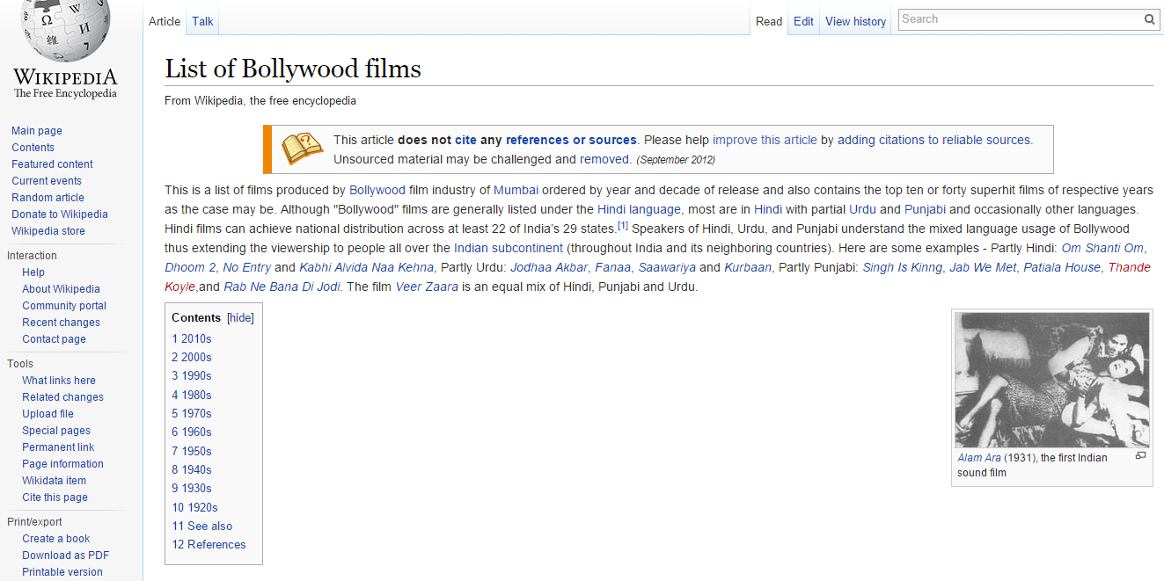

**8.AFTER MID-SEMESTER**

|  |  |  |  |  |
| --- | --- | --- | --- | --- |
| movie_id | movie_name | movie_director | Movie_genre | Movie_imdb_rawlink |

|  |  |  |
| --- | --- | --- |
| Movie_imdb_actuallink | Movie_rating | Movie_image_link |

|  |  |
| --- | --- |
| Movie_imdb_rawlink | Movie_imdb_actuallink |

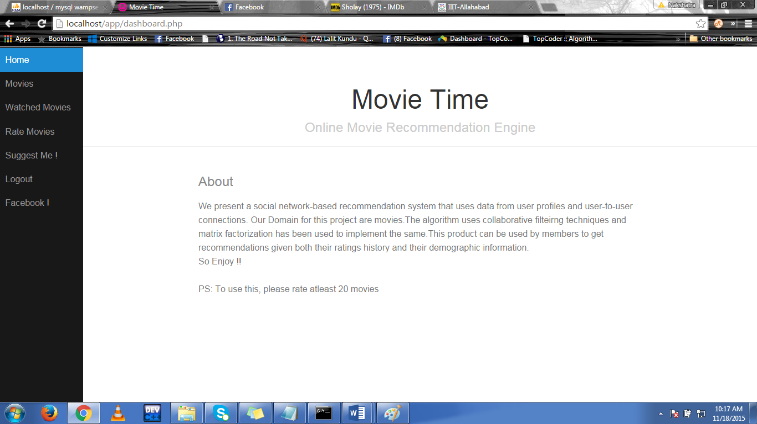

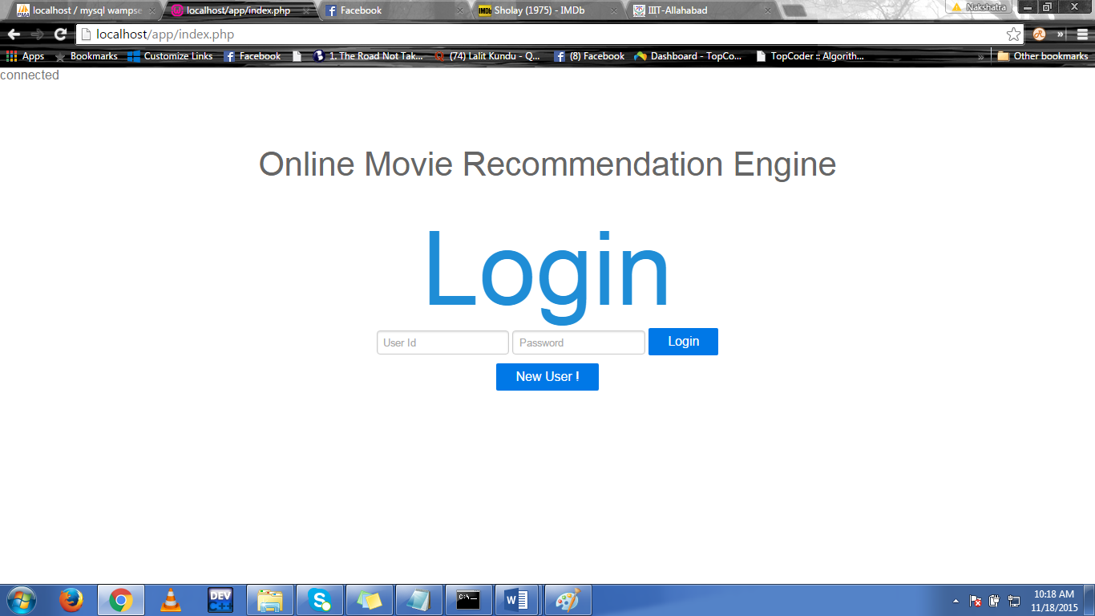

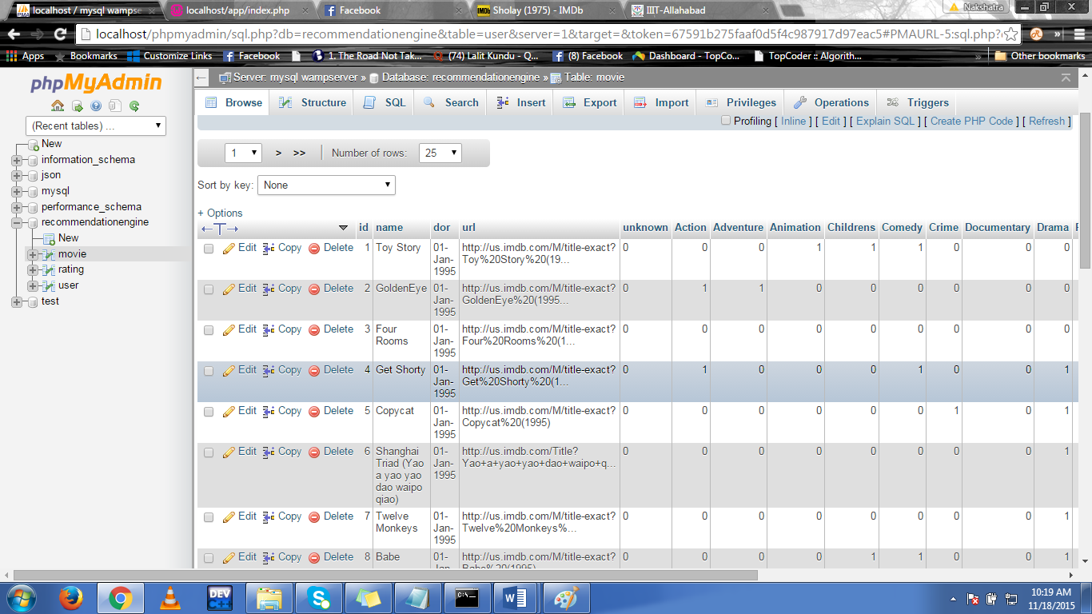

**DATABASE CONTEXTS**

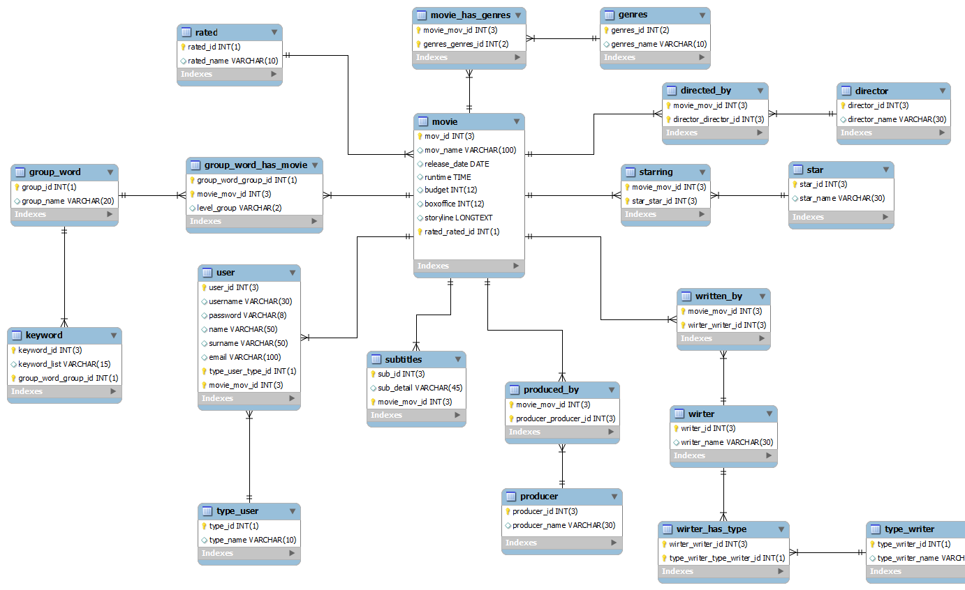

**9. RESULT**

We present a social network-based recommendation system that uses data from user profiles and user-to-user connections. The algorithm uses collaborative filtering techniques and matrix factorization has been used to implement the same. This product can be used by members to get recommendations given both their ratings history and their demographic information.

**10.REFERNCES**

[1] (http://en.wikipedia.org/wiki/Levenshtein_distance)

[2] Anna Huang (2008) ,"Similarity Measures for Text Document Clustering" , Department of Computer Science The University of Waikato, Hamilton, New Zealand.

[3] Tianqui Chen. “ SVDFeature : A Toolkit for Feature-based Collaborative Filtering,” Shanghai Jiao Tong University.

[4] http://www.cnet.com/news/top-10-movie-recommendation-engines/

[5] <http://maheshakya.github.io/gsoc/2014/05/18/preparing-a-bench-marking-data-set-using-singula-value-decomposition-on-movielens-data.html>

[6] Gilda MoradiDakhel,”A New Collaborative Filtering Algorithm Using K-means Clustering and Neighbors’ Voting” Faculty of Electrical, Computer & IT Engineering, Azad University, Qazvin Branch, Qazvin, Iran

REMARKS